AWS ADVANCE LU BATCH 1 PROJECT 1:
CREATING NAT GATEWAY IN AWS:
TASK:
Log into AWS Management console.
Create a VPC (Virtual Private Cloud) :
Amazon VPC is an isolated section or area of the AWS cloud that enables the launching of AWS resources into a virtual network that is defined.
Screenshot for the vpc:
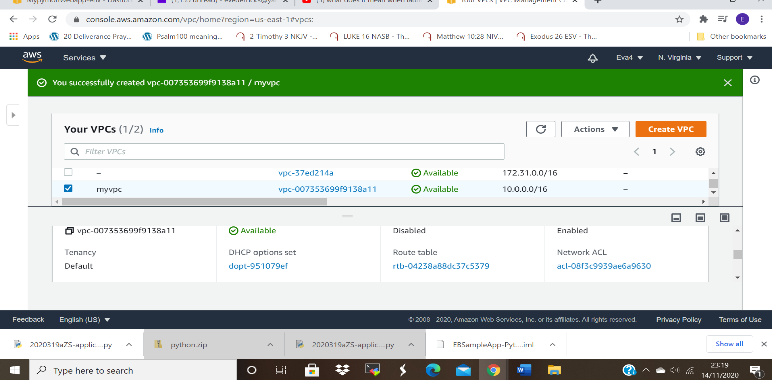

Creating subnets
Subnets are like containers which holds instances in the virtual private cloud.
It enables the isolation of instances from each other.
We have public subnet which have access to internet and private subnet in which any instance built will not have access to the internet.
Screen shot of main Public subnet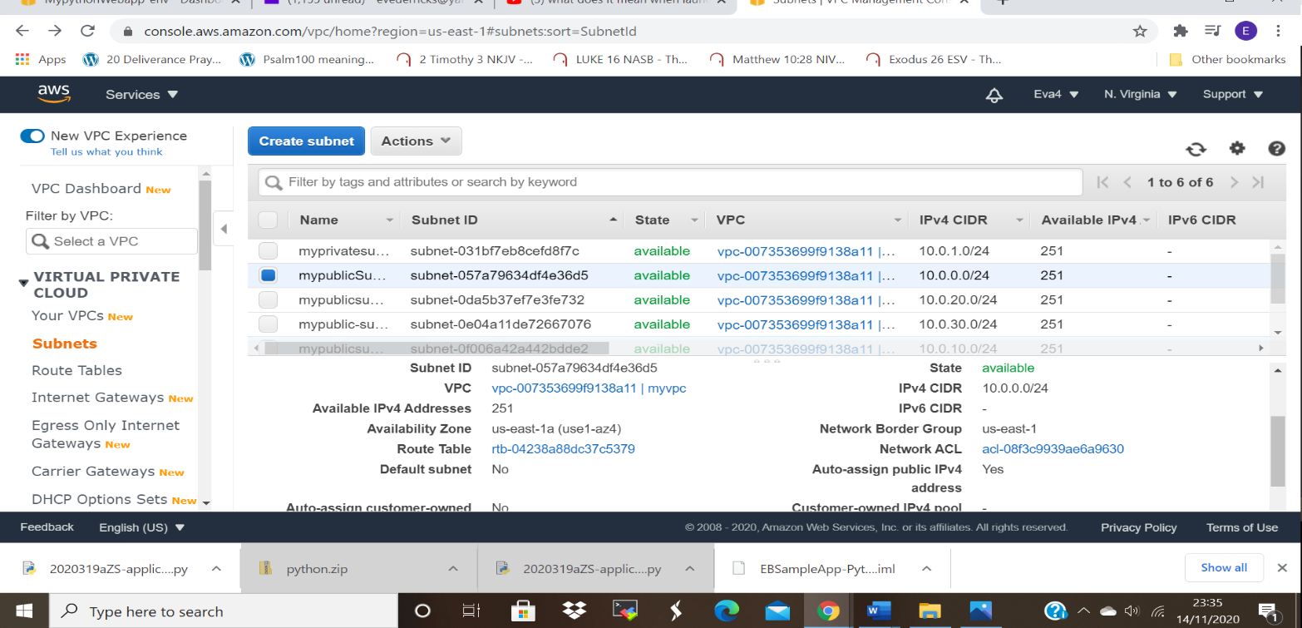

ScreenShot for Private subnet
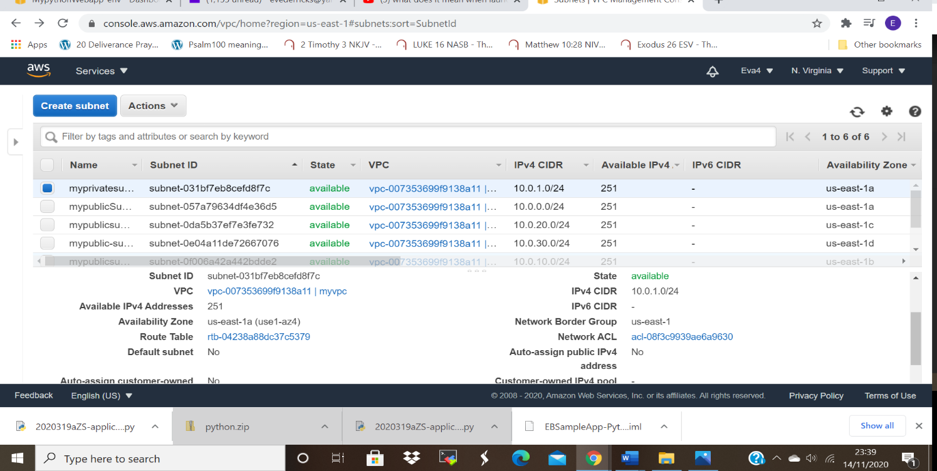

Creating Internet Gateway and Associate with Public subnet:
Internet Gateway is a highly available virtual private cloud component that enables the public subnet to connect to internet.

Screenshot of IGW:
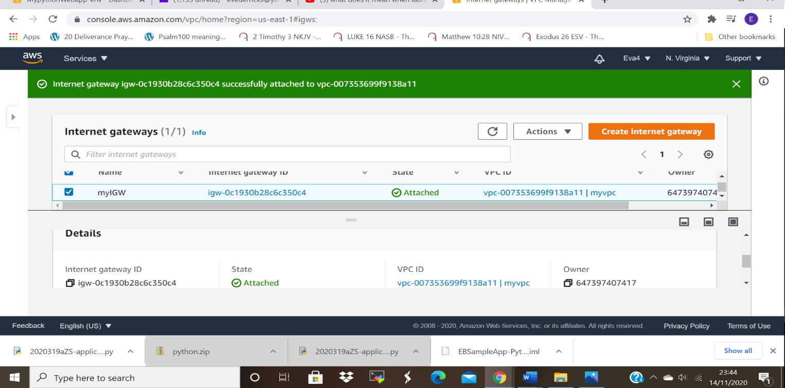

Create a Public Route and associate with public subnets created
Route tables contains set of rules, known as routes which are used to determine where network traffic from subnet or gateway is directed.
In this case we created public Route to connect to public subnet.

Screenshot of the Public Route table: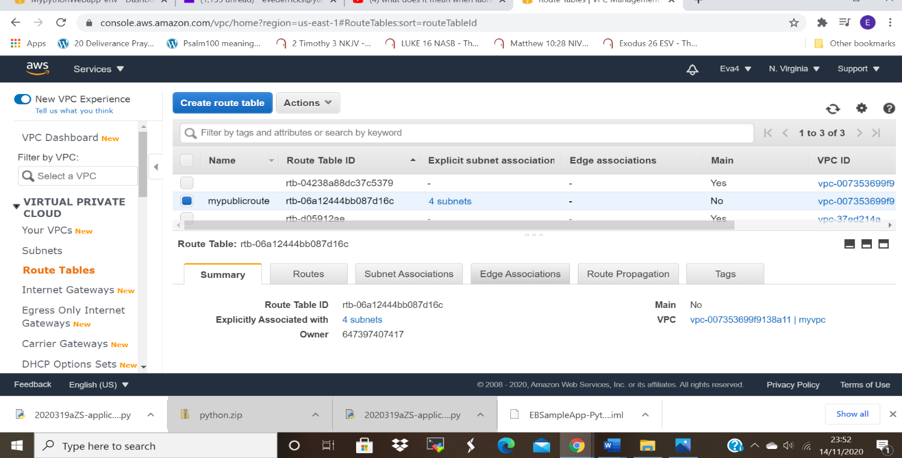

NAT Gateway:
Network Access Translation (NAT Gateway) enables the communication and connection of private subnet to public subnet.
It enables the outbound traffic from private subnet to the internet and prevents inbound traffic from the internet

Screenshot of NAT gateway:
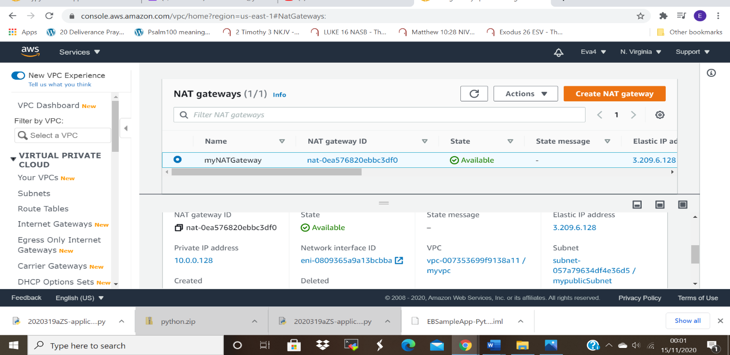

The environment created above will enable us to launch servers both in public and private subnets.
DEPLOYING A HIGHLY AVAILABLE WEB APPLICATION AND BASTION HOST
BASTION HOST
This is a system that is exposed to the internet since it is built in the public subnet, via the Internet Gateway.
It is a computer that acts like a rep server that allows the client machine to connect to the remote server
Create a Bastion Server:
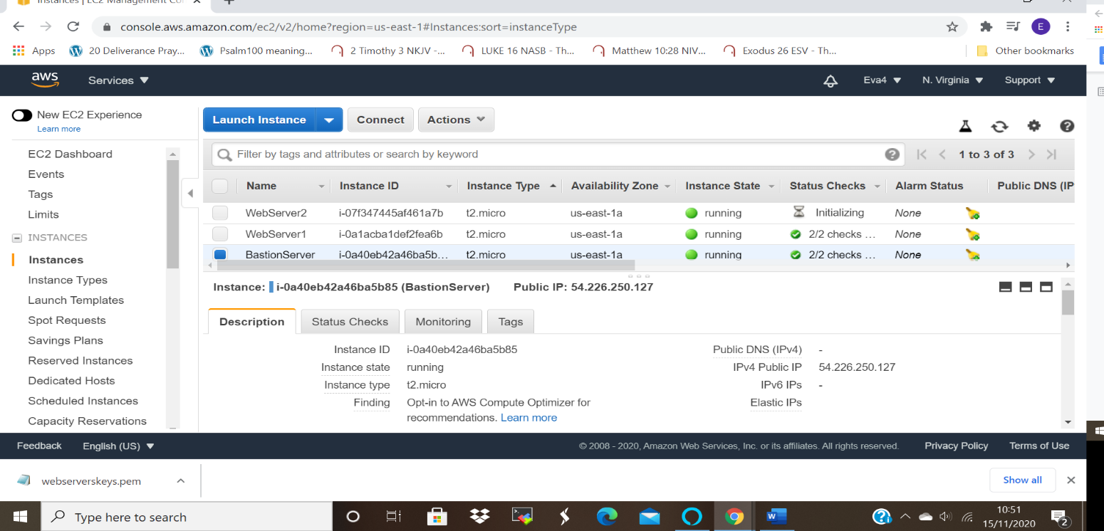

SECURITY GROUPS:
These acts as virtual firewalls for the EC2 instances to control the incoming and outgoing traffic.
We created three security groups, Bastion Server-Sg to control the inbound and out bound traffic into the Bastion server,
Load Balancer -SG for the load balancer and webserver-sg for the webservers.

Screen shot for the Bastion-security group.
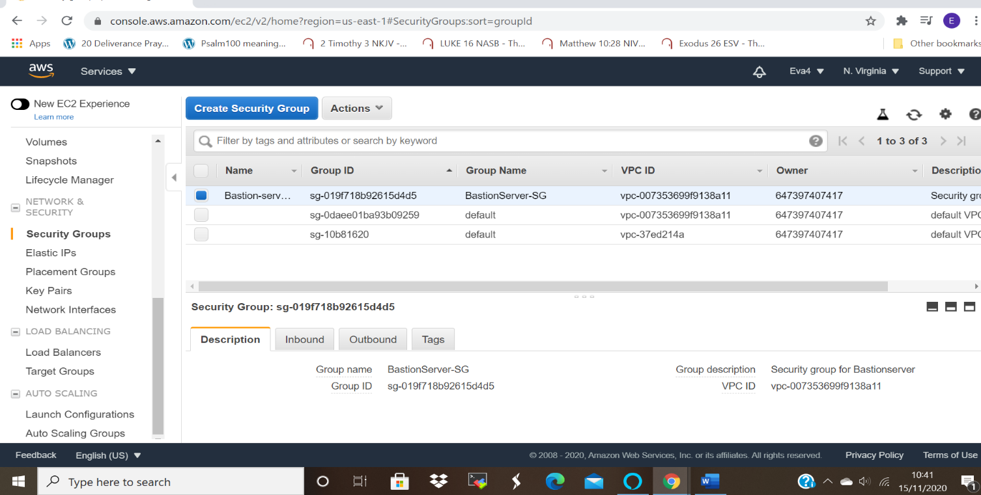
Screenshot for the Load Balancer security group:
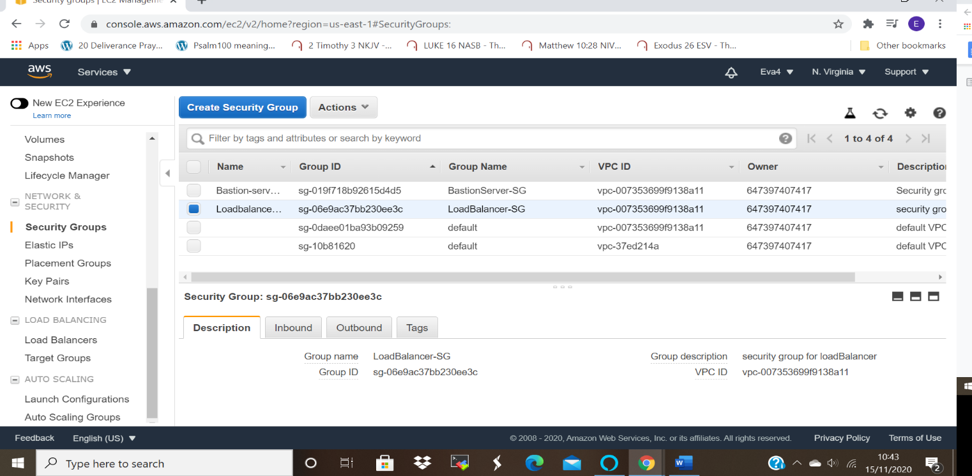

Screenshot of security group for webservers:
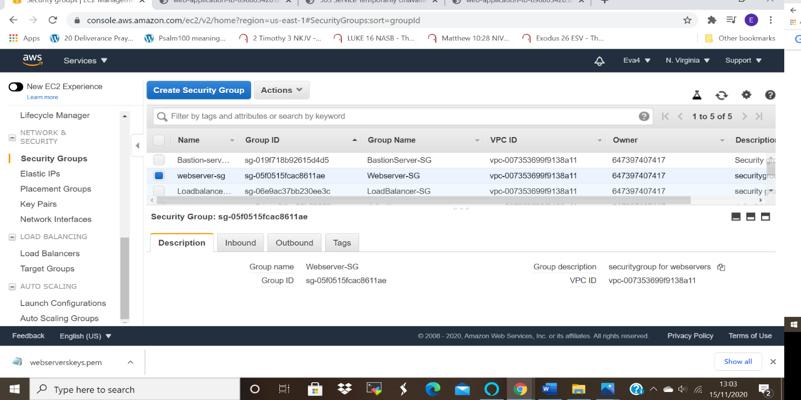

Creating the Webservers:
Webservers AWS are virtual computers that runs and host websites, they also distribute, process and deliver the web pages the users as requested.
In this case we created both webservers in private subnets which means that they do not have direct access to the internet. Hence have to be connected to the Bastion server which is created in public subnet and is able to access the internet via Internet Gateway.

Screenshot of Webserver-1:
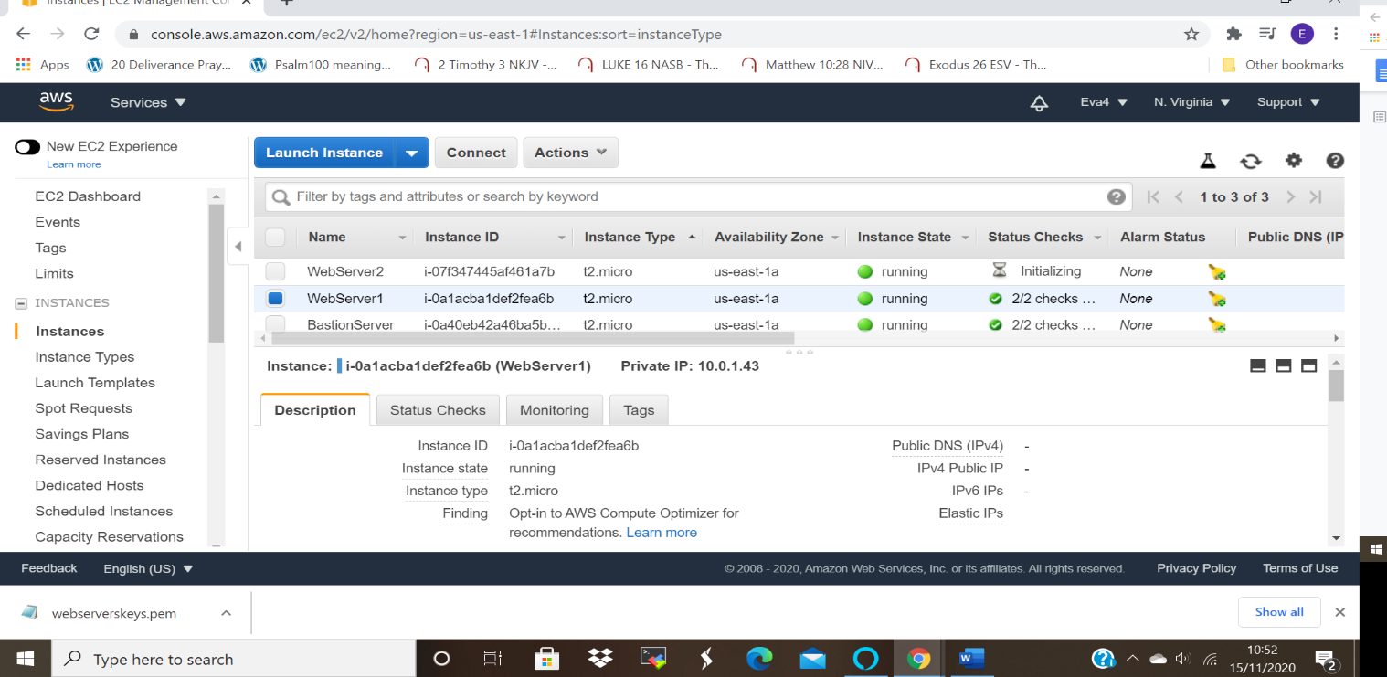

Screenshot of Webserver-2:
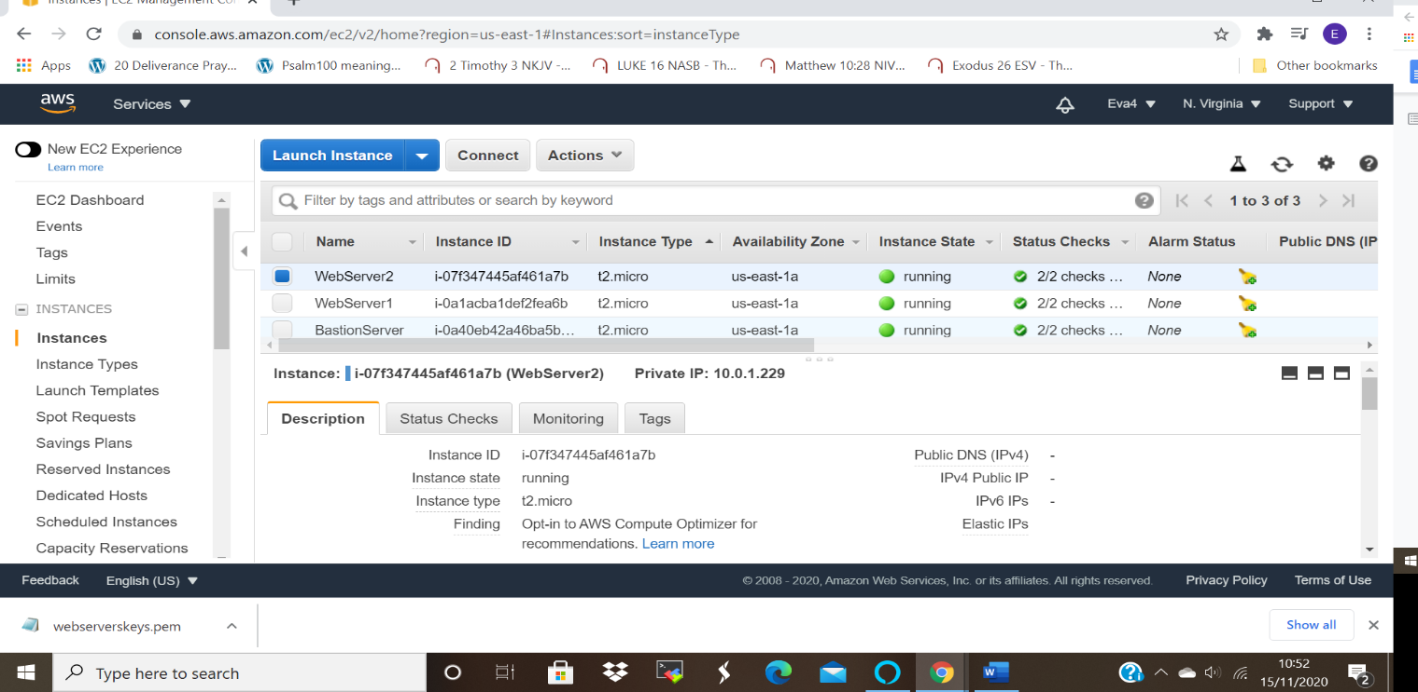

Creating Load balancer:
Load Balancers takes incoming requests from users and routes them to the instances which are registered with load balancer.
This can be in different availability zones.
In this case it used to ensure high availability between the webservers created in the private subnet.
Screenshot for Load Balancer:
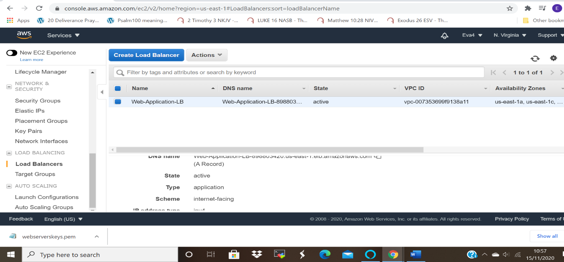

Connecting to webservers via Bastion:
We connect to webservers via Bastion since the webservers were created in the private subnet, they do not have access to the internet,
This is made possible through the Nat gateway created.
The screen shots below show the steps.
Connection to the server is made possible by downloading the webseverskey pem created when launching the servers. And using the given commands

Screenshot below shows that connecting to the webserver1 was successful as the IP address indicates.
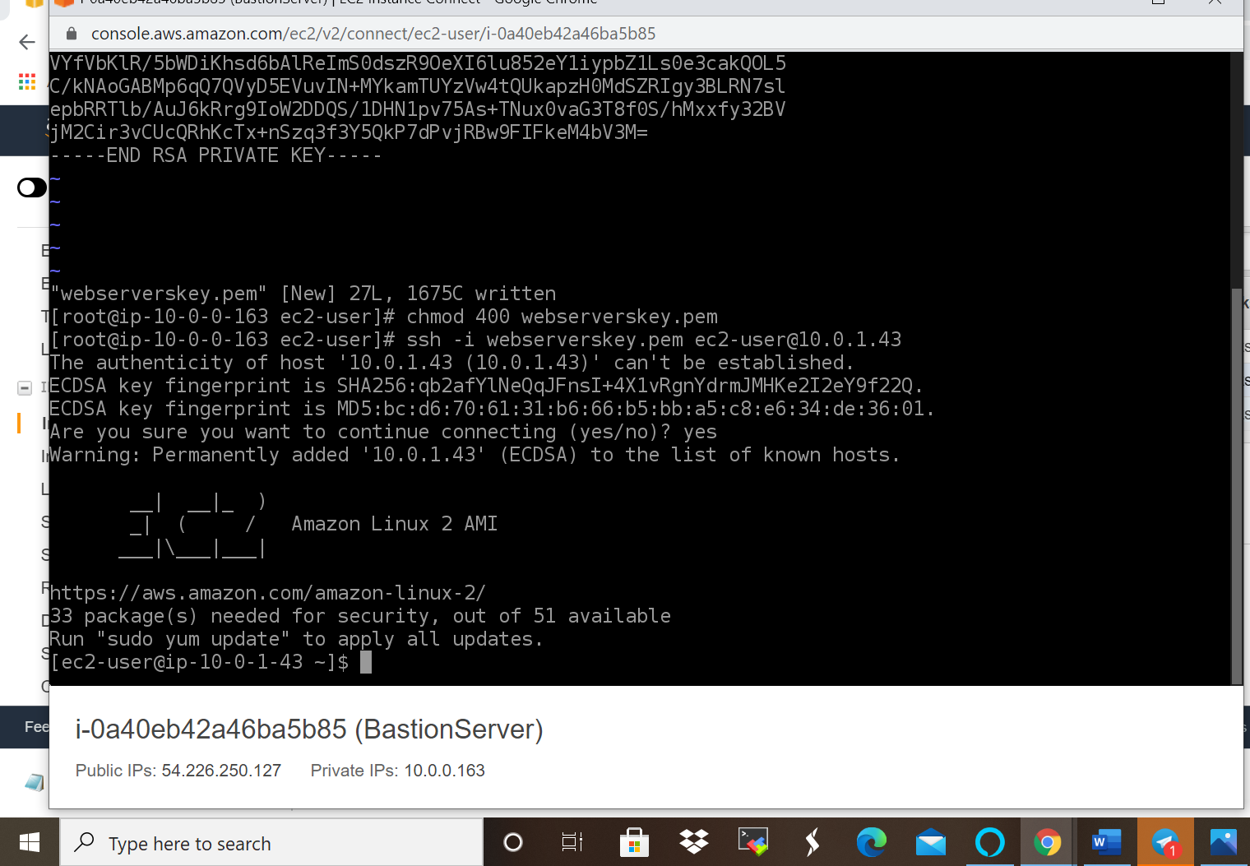

The screenshot below shows the completion of update and installation of files.

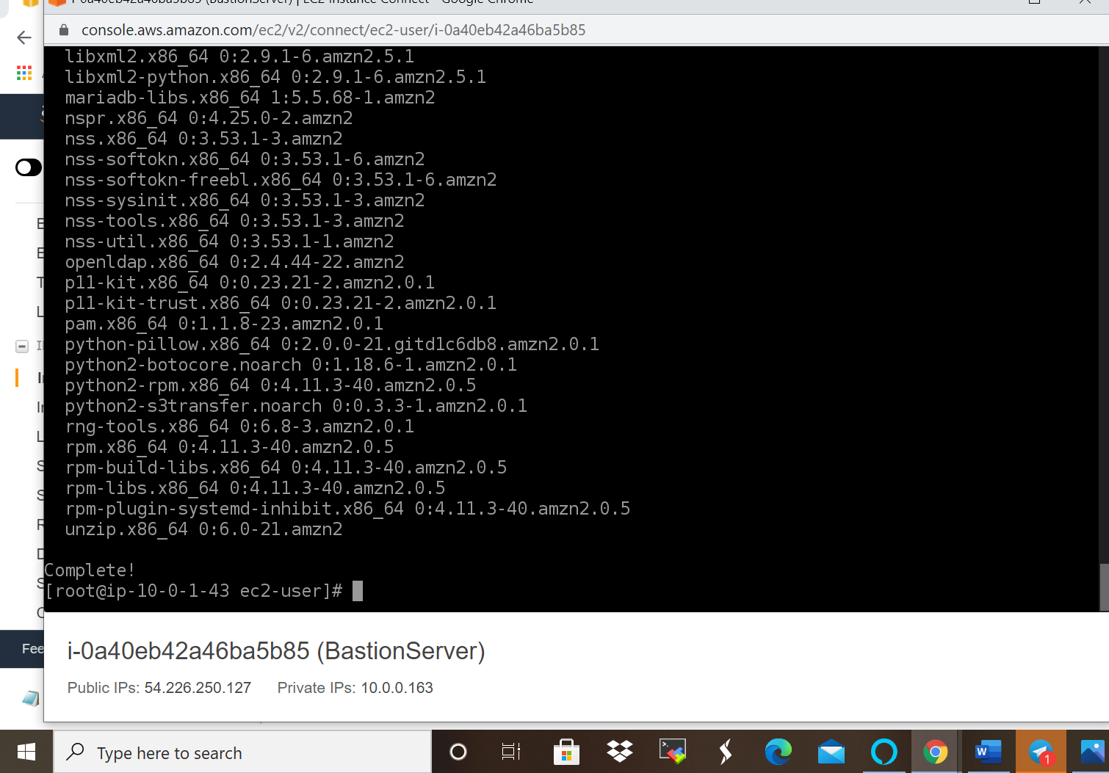
The screenshot below shows the completion of installation of apache service into server 1 and creating index.html file.
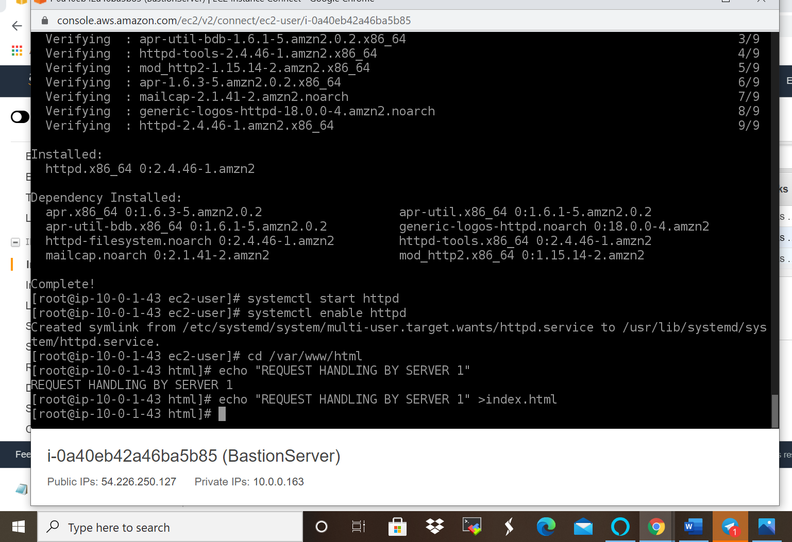
Screenshot show successful log into or connection to server two by exiting the server 1 and switching back to bastion server since it’s the link we have to the internet via natgateway.
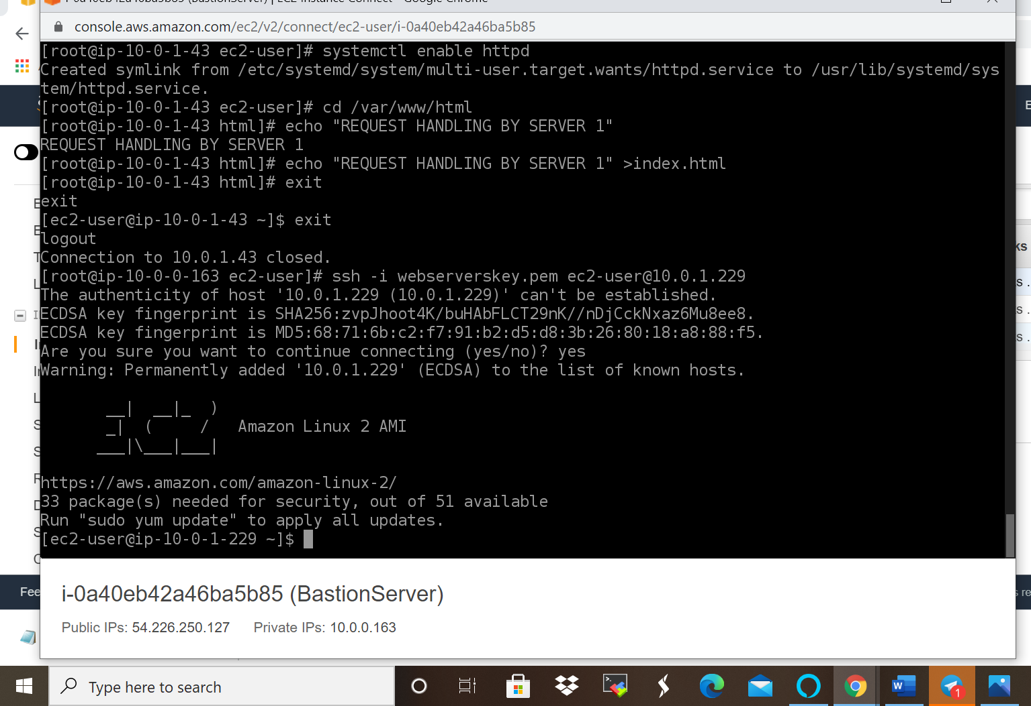

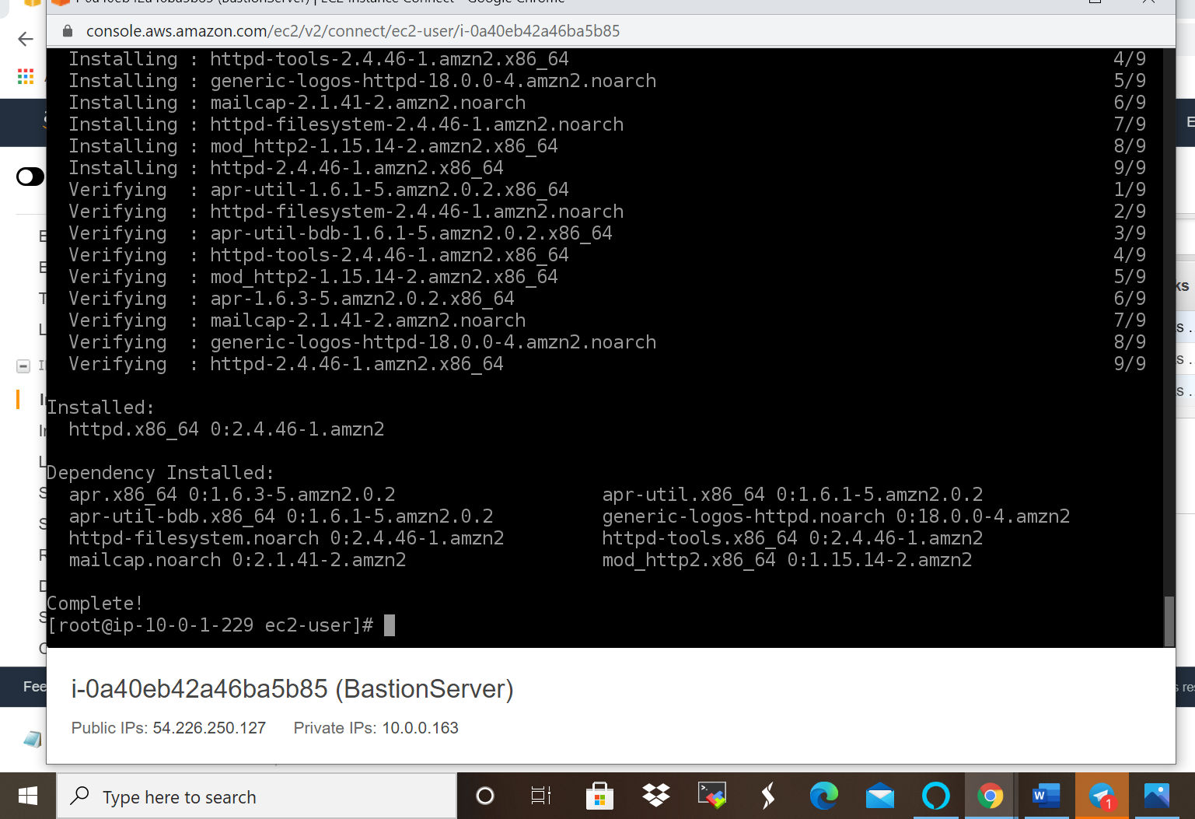

Screenshot afternoon finishing the connection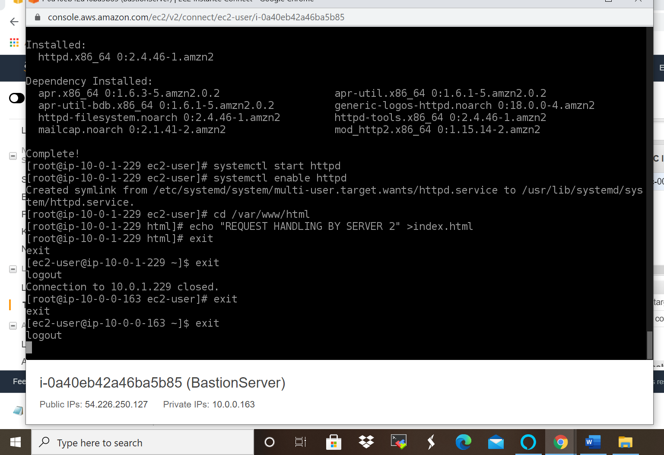

Checking the health of the load Balancer:
After successfully launching the two webservers, the targets group status shows healthy which means we can access the web page of both servers.
Screenshots of the Target group:
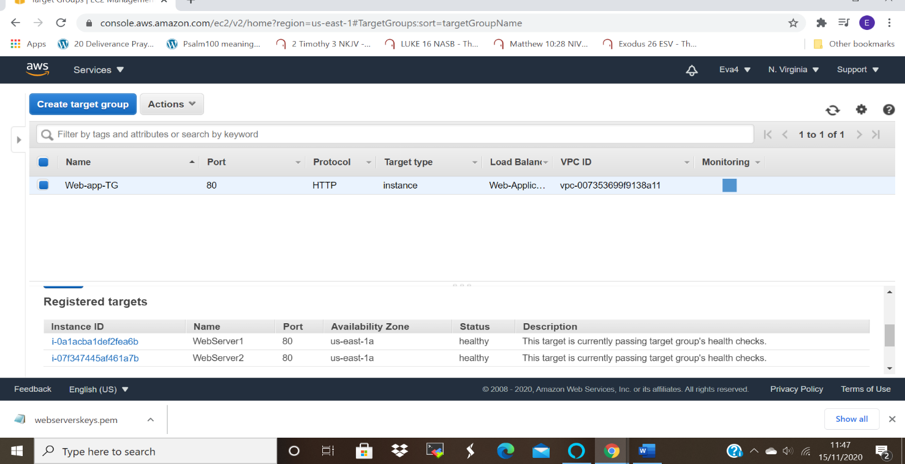

Navigated to the load balancer and copy the DNS URL address and paste it into the browser, this will enable us to access the web pages of the two servers simultaneously.
This is because it is designed to translate webpage names to numeric IP addresses that computer use to connect to each other.
Below are screenshots of both web pages of server one and server 2:
Screenshot webserver1
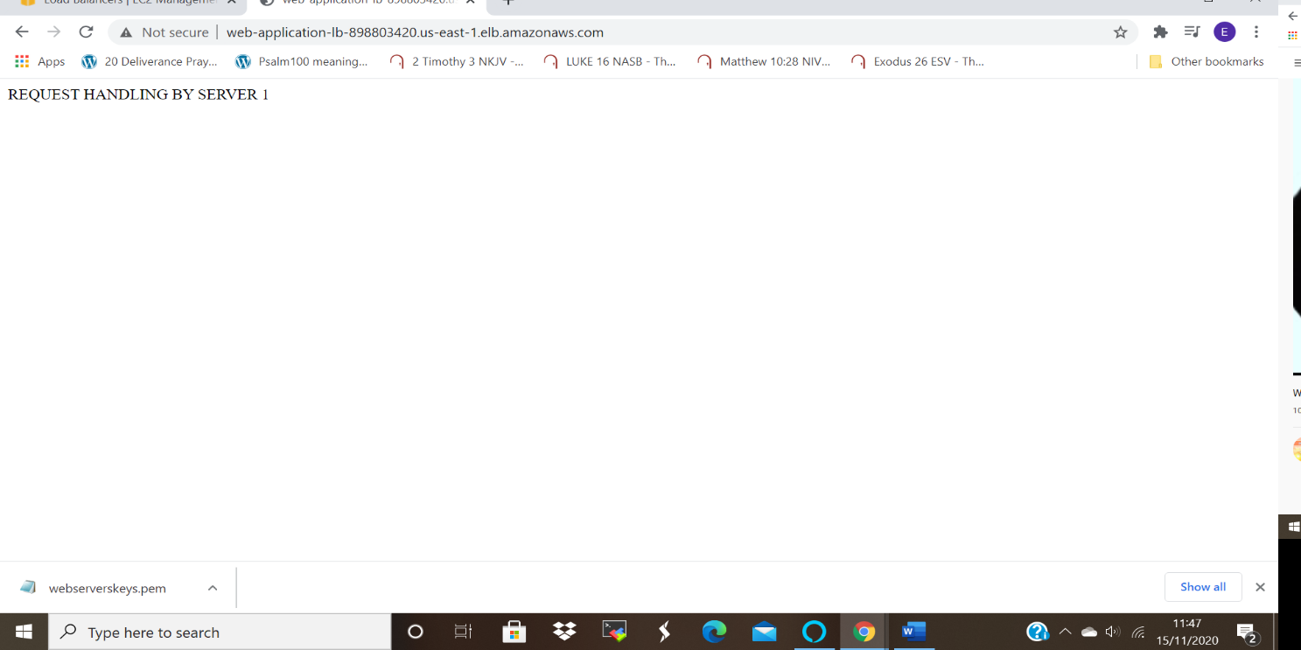
Screenshot of webserver2:
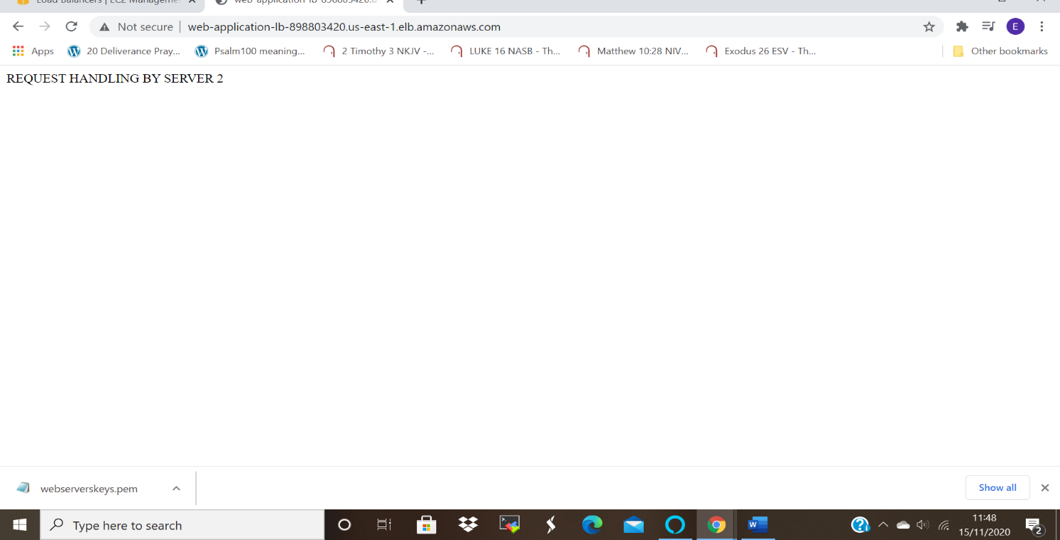

Testing Case for High Availability:
After stopping webserver1 the target group health state turned from healthy to unused.
This did not hinder access webserver 2 as its status was healthy. this shows the high availability as the load balancer was still able route the incoming traffic to it.
As shown in the screenshots below.
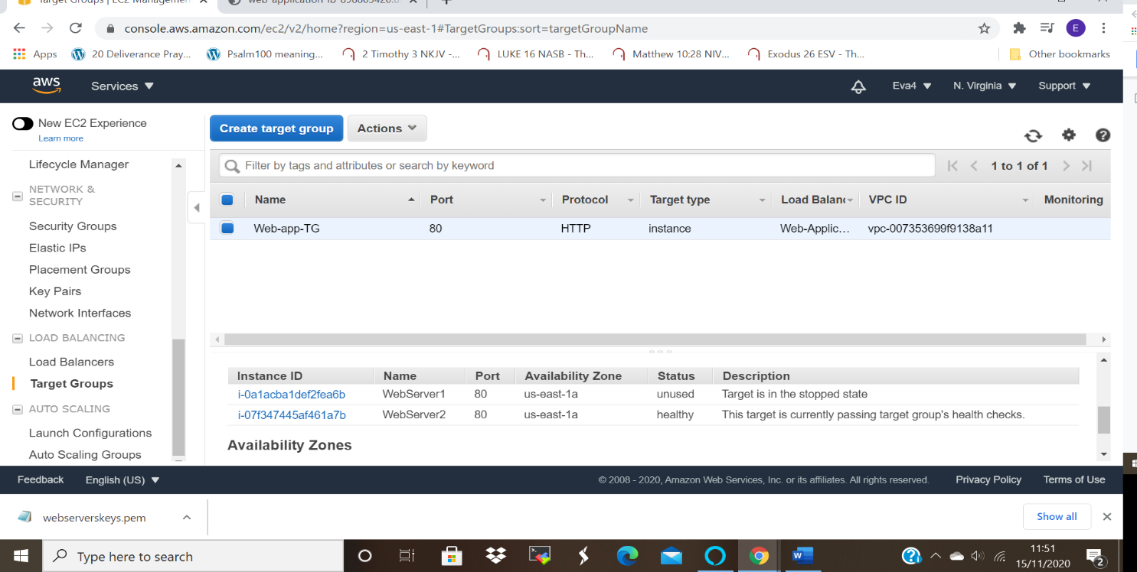

Screenshot for the web page of server 2 after server one was stopped, This is a proof of the high availability deployment, stopping one server does not affect the availability of the other though they are in the same subnet:
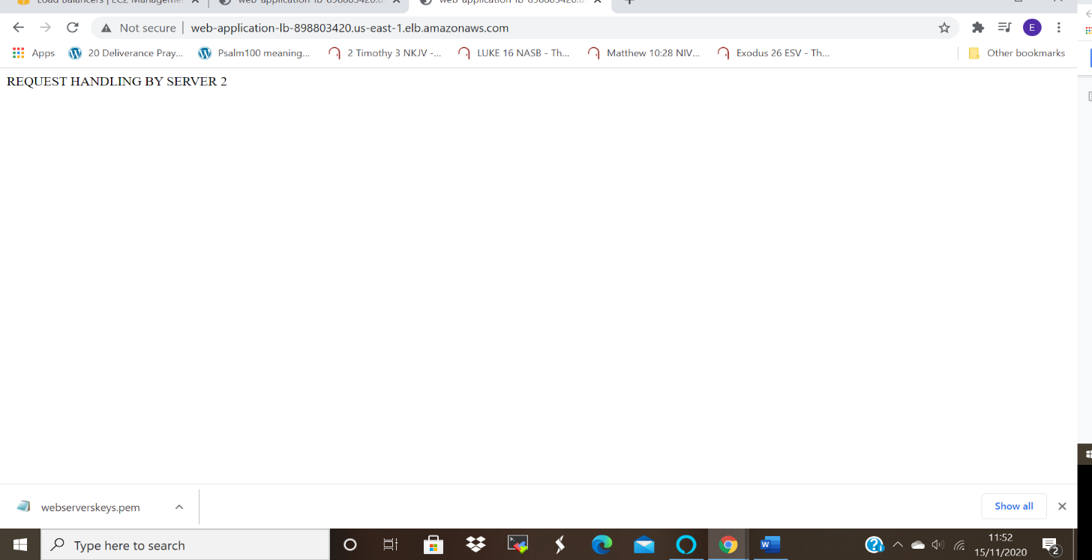

When one server1 is stopped and server 2 is terminating, webpage shows page temporary unavailable, which means once the stopped server is made healthy or restarted, the page can be accessed, as shown in the screenshots below.
Screen shot for web page when server 1 was in stopped state and server to terminating state. Web page temporarily unavailable.

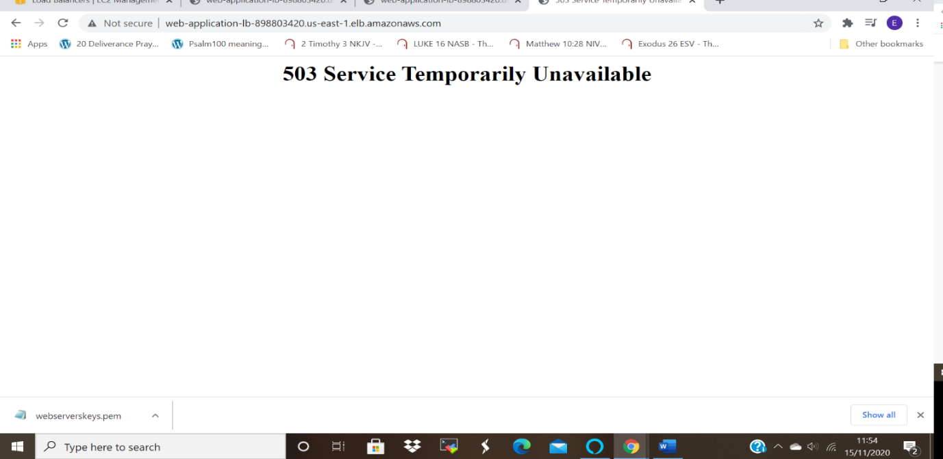

Screenshot of web- page of server 1 after starting the stopped instance:
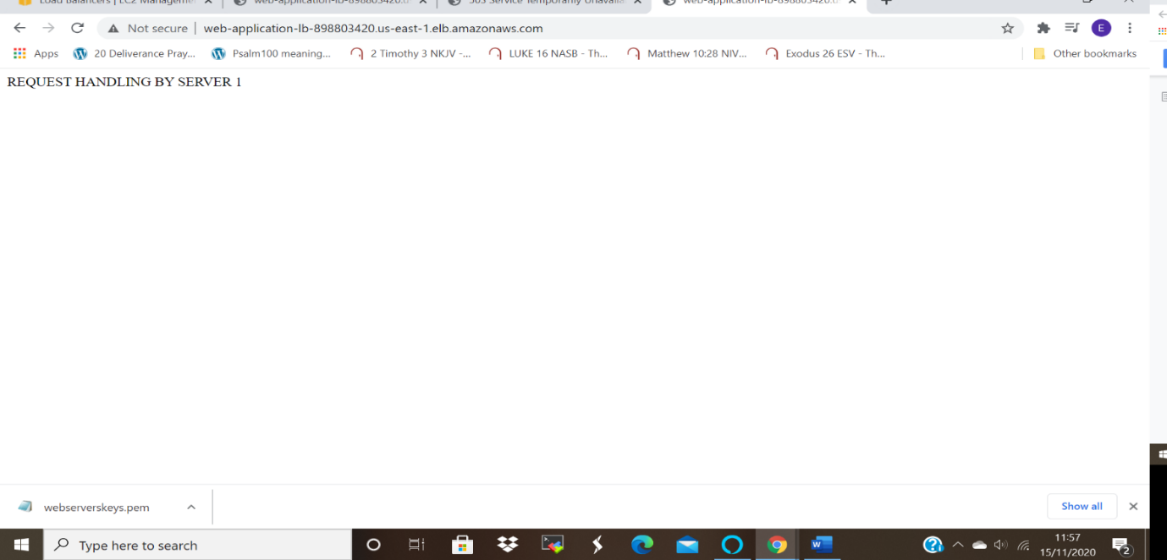

HIGH AVAILABITY
The above implementation enabled the achievement of high availability, since were able to connect access one server when the other was terminated or stopped.

